**Project Report on**

**Guess Wrong Game**

**Course Title:** Software Development IV

**Course Code:** CSE 400

**Program:** B.Sc. Eng. In CSE

**Guided by**

Milon Biswas

Lecturer, Department of CSE

**Prepared by**

|  |  |
| --- | --- |
| **Name** | **Id no.** |
| Sabbir Ahammed | 14152103038 |
| Mallik Mohammad Ashraf | 14152103014 |
| A.S.M Abdullah Zaki | 14152103025 |

Date of Submission: 14 July, 2018



Bangladesh University of Business & Technology (BUBT)

Mirpur, Dhaka.

**Candidate Declaration**

We hereby declare that the project entitled “**Guess Wrong Game**” is an authentic record of our own work carried out as requirements for the award of degree of Bachelor of Science in the Department of Computer Science and Engineering (CSE) at Bangladesh university of Business & Technology (BUBT), Mirpur#2, Dhaka-1216, Bangladesh, under the guidance of Mr. Milon Biswas, lecturer, Dept. of CSE, BUBT.

Sabbir Ahammed

ID: 14152103038

Date: ………………….

A.S.M Abdullah Zaki

ID: 14152103025

Mallik Mohammad Ashraf

ID: 14152103014

**To Whom It May Concern**

This is to certify that Sabbir Ahammed , A.S.M Abdullah Zaki, Mallik Mohammad Ashraf , students of Bachelor of science in the department of Computer Science and Engineering (CSE) at Bangladesh university of Business and Technology (BUBT) has completed their project work entitled ‘Guess Wrong Game’ is satisfactory and adequate in scope and quality as a project.

Supervisor

**Mr. Milon Biswas**

Lecturer, Dept. of CSE

Bangladesh university of Business and Technology

Mirpur-2, Dhaka-1216, Bangladesh.

**Abstract**

This “**Guess Wrong Game**” intended to be our project of Bangladesh University of Business & Technology (BUBT) in care of Mr. Milon Biswas, lecturer, department of CSE, faculty of Engineering. The idea is to create a quiz game where a player has to choose wrong answer instead of correct answer. Generally, every quiz game consists of different questions specific to the context of the player, and the players have to answer correctly to proceed. Our game is just the opposite of all the traditional quiz games. Here, a player has to choose the wrong answer from the available options of a question. If can choose the wrong answer correctly, then he can gain some points and proceed through the game. Otherwise, he will lose. This is the main concept of our game. The idea is to make the player choose the wrong answer from existing correct answers in a way that it is fun. And another thing is to check how the human brain reacts when he almost knows the correct answer still have to give the incorrect.

|  |  |  |
| --- | --- | --- |
| **Chapter no. & Chapter name** | | **Page no.** |
| **Chapter 1- Introduction** | | 6-9 |
| 1.1 | What is Guess Wrong Game | 7 |
| 1.2 | The aim of the System | 7 |
| 1.3 | Project Life Cycle | 8 |
| 1.3.1 | Project initiation | 8 |
| 1.3.2 | Project execution | 8 |
| 1.3.3 | Project development | 9 |
| 1.4 | Methodology | 9 |
| **Chapter 2- Literature Review** | | 10-15 |
| 2.1 | What is literature review? | 11 |
| 2.2 | System Analysis | 11 |
| 2.2.1 | Existing system | 11 |
| 2.2.2 | Propose system | 11 |
| 2.3 | Questionnaires | 11 |
| 2.4 | Observation/Survey | 13 |
| **Chapter 3 - System Design Models** | | 16-17 |
| 3.1 | Data flow diagram | 17 |
| **Chapter 4 – System Implementation** | | 18-26 |
| 4.1 | The systems development life cycle | 19 |
| 4.2 | Waterfall method | 20 |
| 4.3 | Tools | 21 |
| 4.4 | Screenshots | 21 |
|  | **Chapter 5 - Limitations & Conclusion** | 27-28 |
| 5.1 | Limitation | 28 |
| 5.2 | Future implementation | 28 |
| 5.3 | Conclusion | 28 |

**Index**

|  |
| --- |
| **Chapter – One**  **Introduction** |

**1.1 What is Guess Wrong Game?**

This paper gives a description of our work for the project “Guess Wrong“ for the course Software development-4. “Guess Wrong” is a quiz game in which the player has to choose the wrong answer, instead of choosing the right answer. The goals of the project are to create a game, which is fun to play and the player can gain knowledge. We decided to create our game with “Android Studio”. Nobody of our group had any experience in creating games with this software, except of the individually created projects, which we had to do the week before starting the group project. The team decided to split the work of the group project, and therefore we were responsible to create the quiz part for the game.

**1.2 The aim of the System**

There are 4 big goals of the quiz game:

* Motivate the users to answer new questions: It is very important that there are always new interesting questions in the quiz game, otherwise the quiz will get boring and nobody would like to play it.
* Therefore, a ranking with the amount of created questions for each user is displayed on the start screen.
* The player with the most answered questions will get a reward.
* Motivate users to learn: The users should be motivated to gain knowledge
* This is down via a competition between the users, therefore another ranking with the actual score of each user depending on the correctly wrong answered questions is displayed on the start screen.
* Answering new questions should be very fast and easy: When the user for example is reading an article about a new technology and has a good concept in his/her mind, then it should be very fast and easy to answer this question in the game. If it is a pain, the user would not answer the question.
* The game should be fun: The users should like to play the game, because it is fun:
* Players have to answer funny questions.
* They have answer the wrong option instead of right. This a different thing from all other games.

**1.3 Project Life Cycle**

The project life cycle includes various development phases that occur in the life of project starting right from the inception of the project to its final development at the user’s end. The three development phases in a project life cycle are:

• Project initiation

• Project execution

• Project deployment

**1.3.1 Project initiation**

The project initiation phase is first phase of life cycle. This phase involves creating a complete plan for the project, specifying various activities that will be performed and assigning responsibilities to team members on the basis of their skill set.

**1.3.2 Project execution**

After the project plan is made and the responsibilities assigned, the actual development of the project starts. The phase in which the actual development of the project takes place is known as the project execution phase. This is the most crucial phase of any project and is subdivided into the following phases;

1. System analysis

• Initial study

• Information gathering

• Feasibility study

2. System design

• Design standard

• High level design & design tools

• Logical design

• Construction

3. System implementation

• integration & testing

• post implementation

**1.3.3 Project development**

After the project execution phase, the final phase of a project life cycle is the project development phase. In this phase, the system deployed at the client side. This phase also involves providing customer support to the client for some specified period of time.

When the project is built it may possibly not remain errorless, because several type of modification can take place several times. So for the very first time when we run the project we found few problems in tools portions. We fixed this problem including some minor problems immediately, and afterwards the application runs properly.

**1.4 Methodology**

Methodology is a collection of procedure, techniques, tools and documentation aids that help the system development in their effort to implement a new information system. The proposed methodology is planned to meet the objective of Guess Wrong Game in an effective way.

|  |
| --- |
| **Chapter – Two**  **Literature Review** |

**2.1 What is literature review?**

A literature review is a text of a scholarly paper, which includes the current knowledge including substantive findings, as well as theoretical and methodological contributions to a particular topic. Literature reviews are secondary sources, and do not report new or original experimental work. Most often associated with academic-oriented literature, such reviews are found in academic journals. Literature reviews are a basis for research in nearly every academic field. A narrow-scope literature review may be included as part of a peer-reviewed journal article presenting new research, serving to situate the current study within the body of the relevant literature and to provide context for the reader. In such a case, the review usually precedes the methodology and results sections of the work.

**2.2 System Analysis**

In this part we discuss all of the query and problem of our project and try to find the solution.

**2.2.1 Existing System**

The existing quiz games available on the internet are have to choose the right answer of the questions. If the wrong answer is chosen, the player lost the game.

**2.2.2 Propose System**

But in our game, a player has to choose the wrong answer from the available options of a question. If he/she can choose the wrong answer correctly, then he can gain some points and proceed through the game. Otherwise, he will lose. This totally different from other quiz games.

**2.3 Questionnaires**

Questionnaires provide an alternative to interviews for finding out information about a system. We would like to add following questions for gathering requirements:

1.  In which part you want more facilities in this game?

1. Information
2. Playing
3. Clearness of each interface
4. Other

2.  Do you find any bug (error) in this game?

1. Yes
2. No

3.  In which part you find bug (error) in this game?

1. Scoring
2. Playing
3. Level up or down
4. I didn’t find any bug.

4. Are you satisfied with our game?

1. Yes
2. No

5. How much satisfied are you about the game?

1. It’s OK
2. Nice
3. Awesome
4. Not satisfied

6. Do you want a updated version of this game?

1. Yes
2. No

7. How much do you prefer the game with other quiz games?

1. Low
2. Medium
3. High
4. Very high

**Descriptive Questions**

1. What do you want to be the system like?

2. List your top priorities for improving this technology.

**2.4 Survey**

From the above questionnaires, we complete our observation of users of the system. The questions and their observation reports are given below:

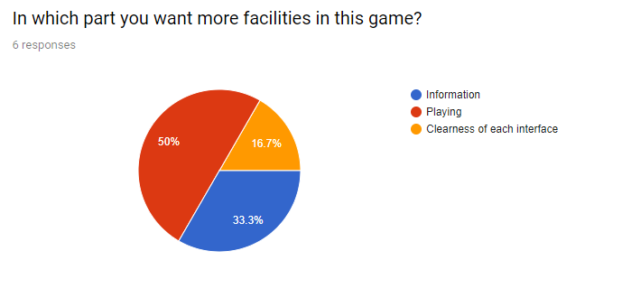

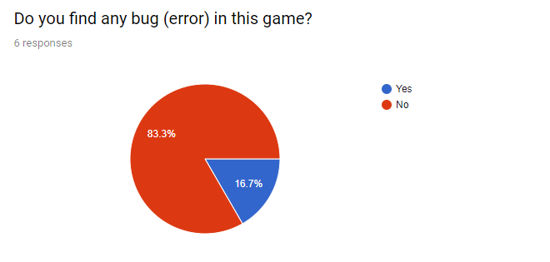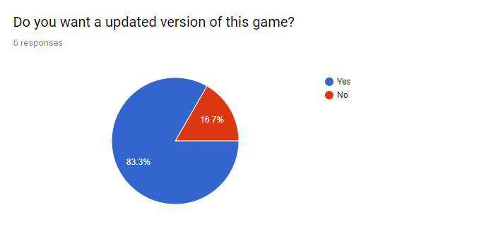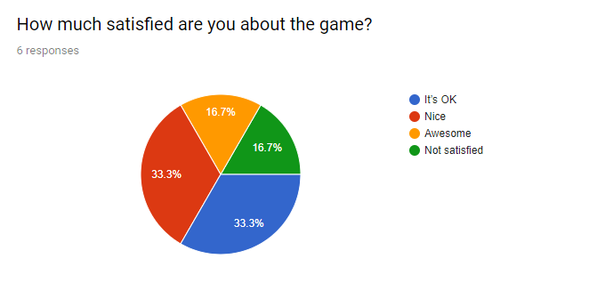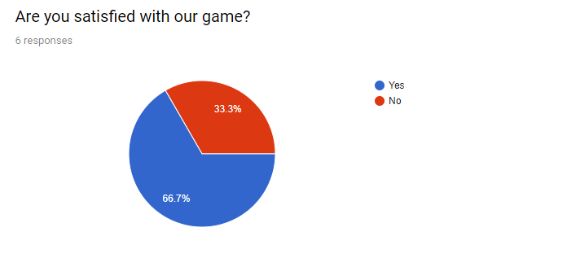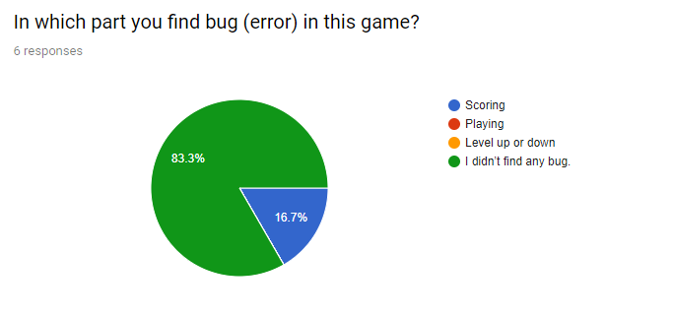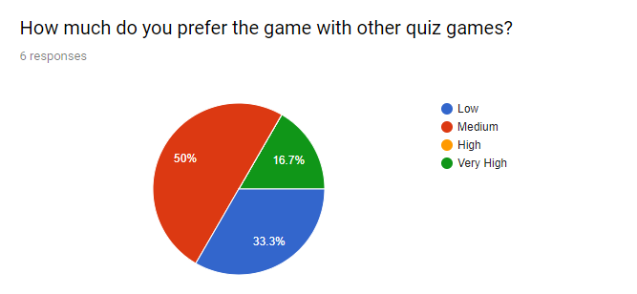

|  |
| --- |
| **Chapter – Three**  **System Design Models** |

In our Guess Wrong Game, we used context level data flow diagram that is shown below:

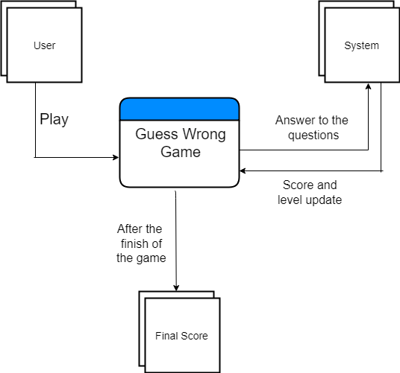

Fig: Data flow diagram of Guess Wrong Game.

|  |
| --- |
| **Chapter – Four**  **System Implementation** |

**4.1 The systems development life cycle**

Throughout this chapter we have referred to the systematic approach we take to the analysis and design of information systems. Much of this is embodied in what is called the “systems development life cycle” (SDLC). The SDLC is a phased approach to analysis and design. That holds that systems are best developed through the use of a specific cycle of analyst and user activities.

Analysts disagree on exactly how many phases there are in the SDLC, but they generally laud its organized approach. Here we have divided the cycle into seven phases, as shown in Figure 4.1.

Although each phase is presented discretely, it is never accomplished as a separate step. Instead, several activities can occur simultaneously, and activities may be repeated.

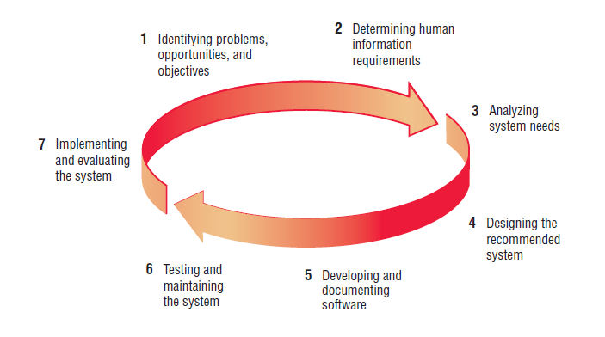

Figure 4.1: The seven phases of the systems development life cycle.

The SDLC model mainly consists of seven phases, which are:

1. Identifying problems, opportunities and objectives.

2. Determining human information requirements.

3. Analyzing system needs.

4. Designing the recommended system.

5. Developing and documenting software.

6. Testing & maintaining the system.

7. Implementing the system.

**4.2 Waterfall method**



Figure 4.2: List of waterfall method.

Waterfall approach was first SDLC Model to be used widely in Software Engineering to ensure success of the project. In "The Waterfall" approach, the whole process of software development is divided into separate phases. In this Waterfall model, typically, the outcome of one phase acts as the input for the next phase sequentially.

The following illustration is a representation of the different phases of the Waterfall Model.

1. Requirement Analysis

2. System Design

3. Implementation

4. System Testing

5. System Deployment

6. System maintenance

**4.3 Tools**

Both software and hardware components were needed to develop this game. They are given below.

Software Components:

* Android Studio

Hardware Components:

* Processor Core i7
* Ram 8gb
* Android Phone

Programming Languages:

* Java
* XML

**4.4 Screenshots**

Some screenshots from the game is given below:



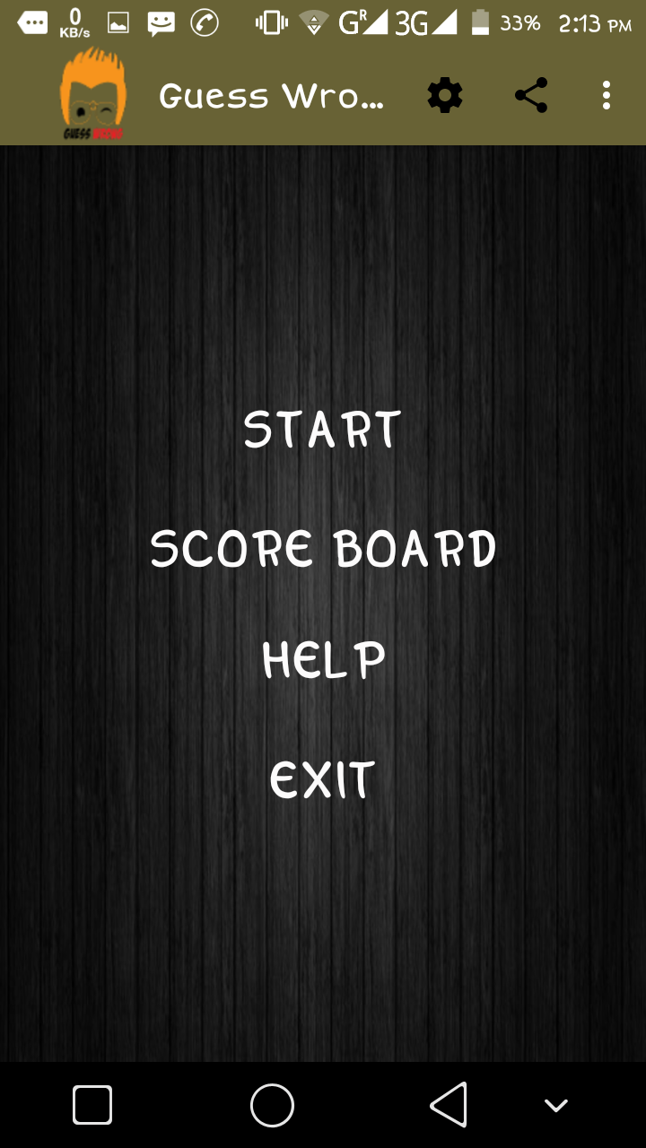

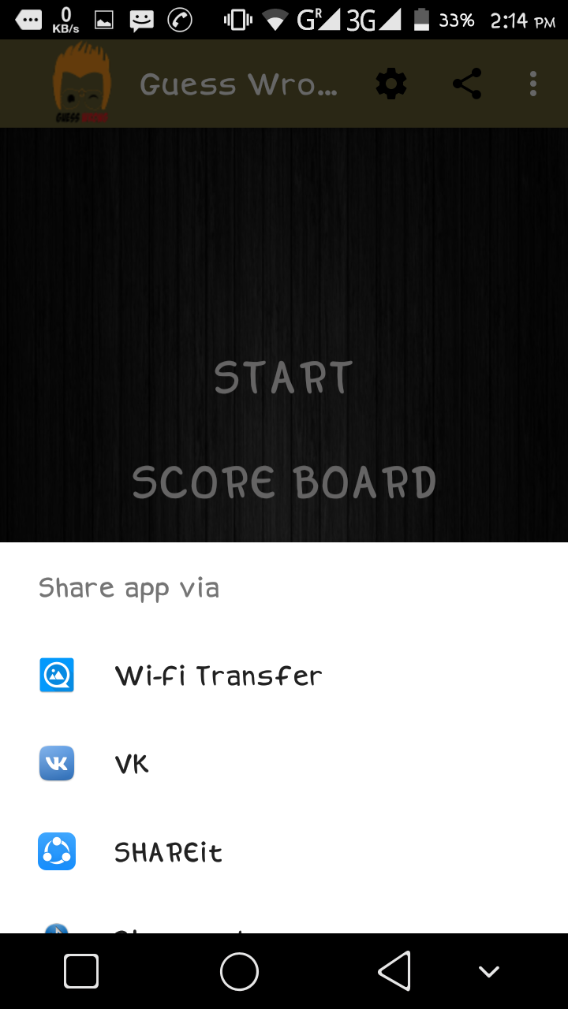

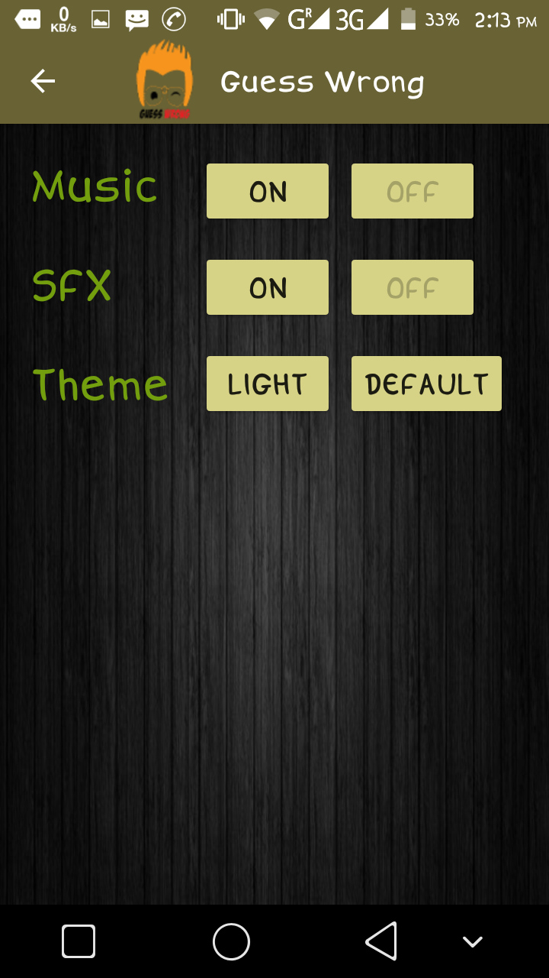

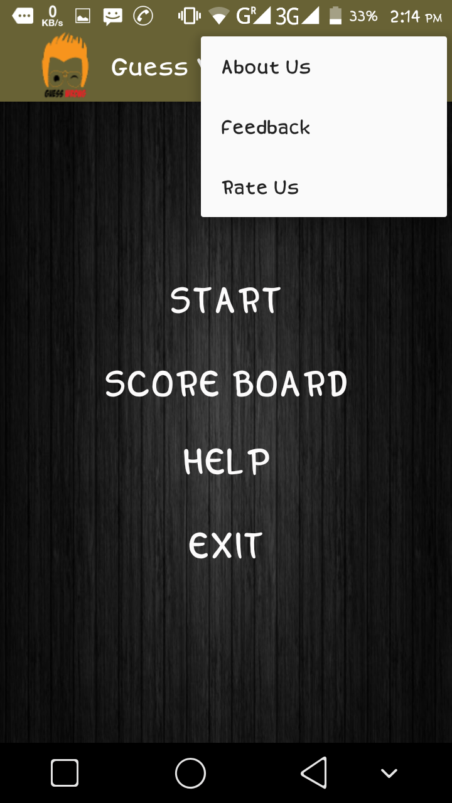

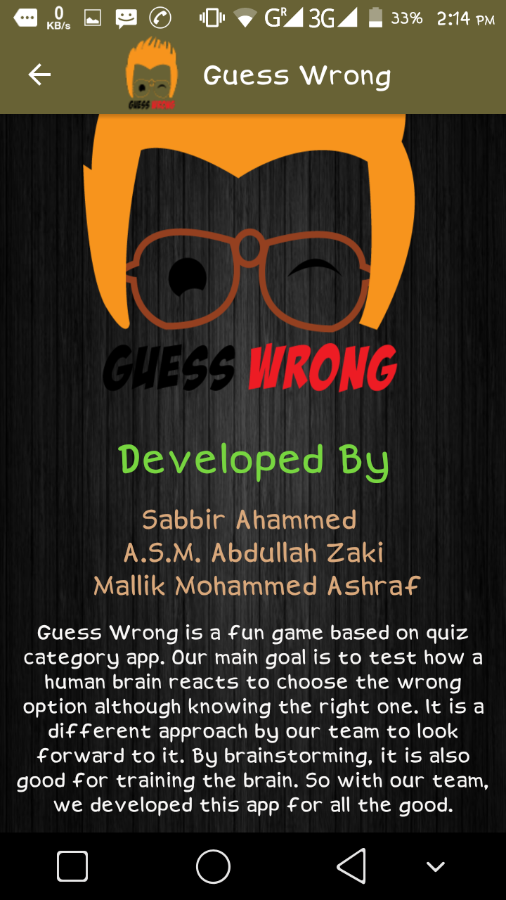

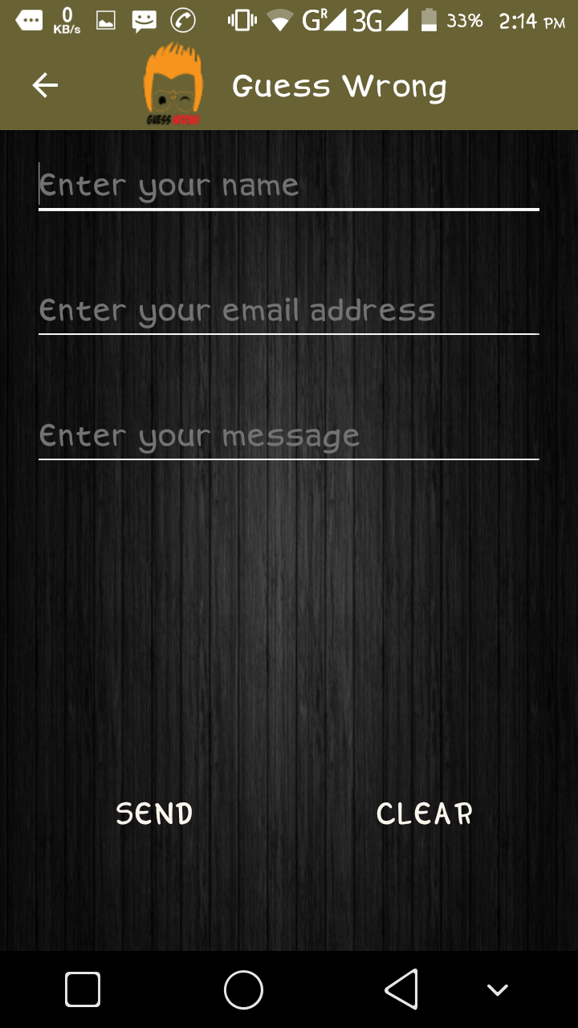

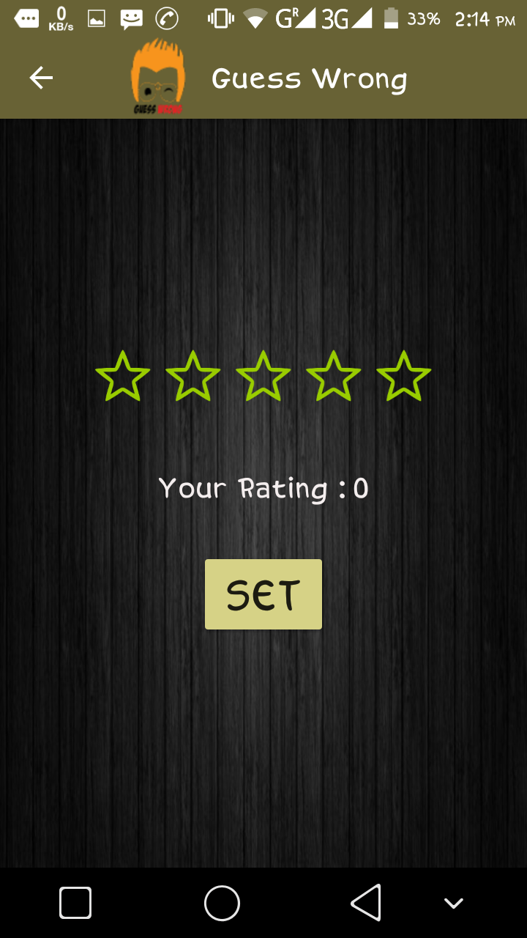

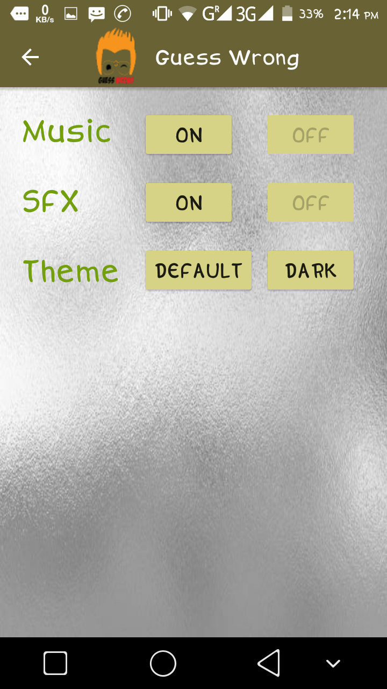

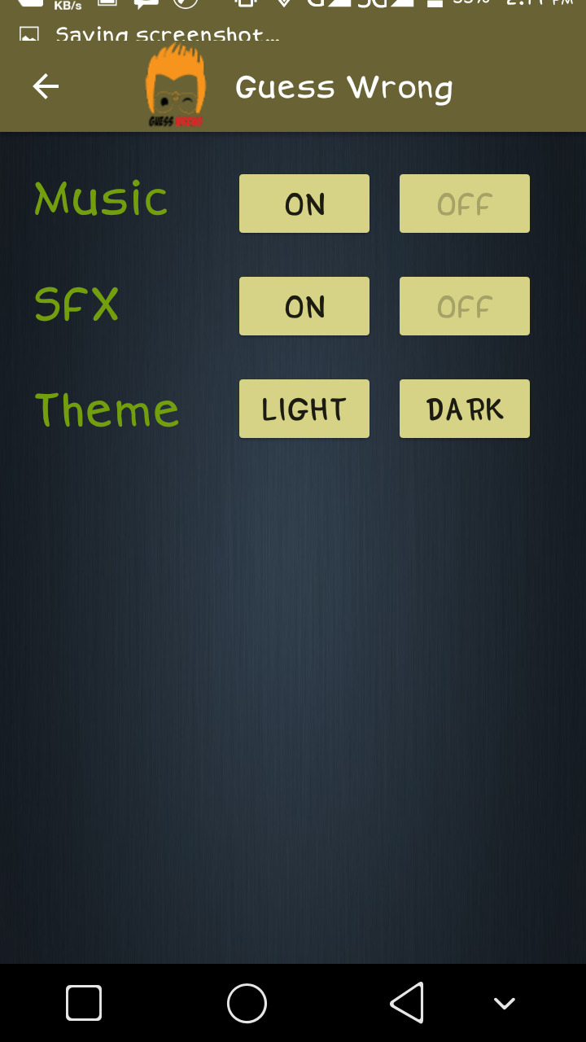

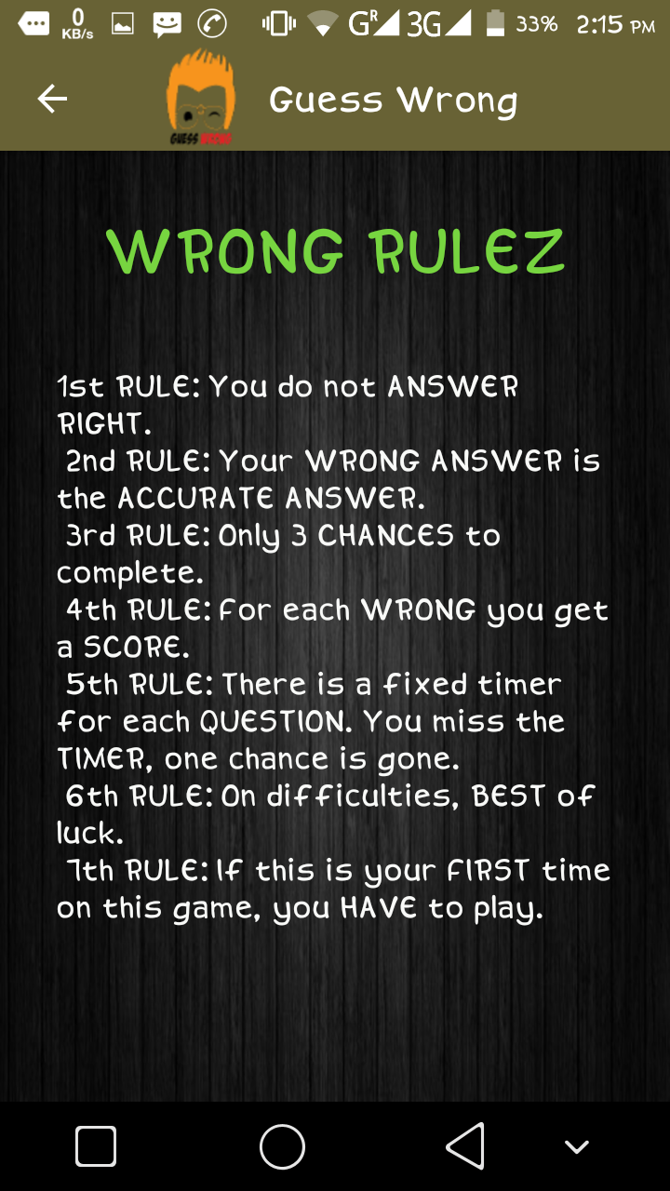

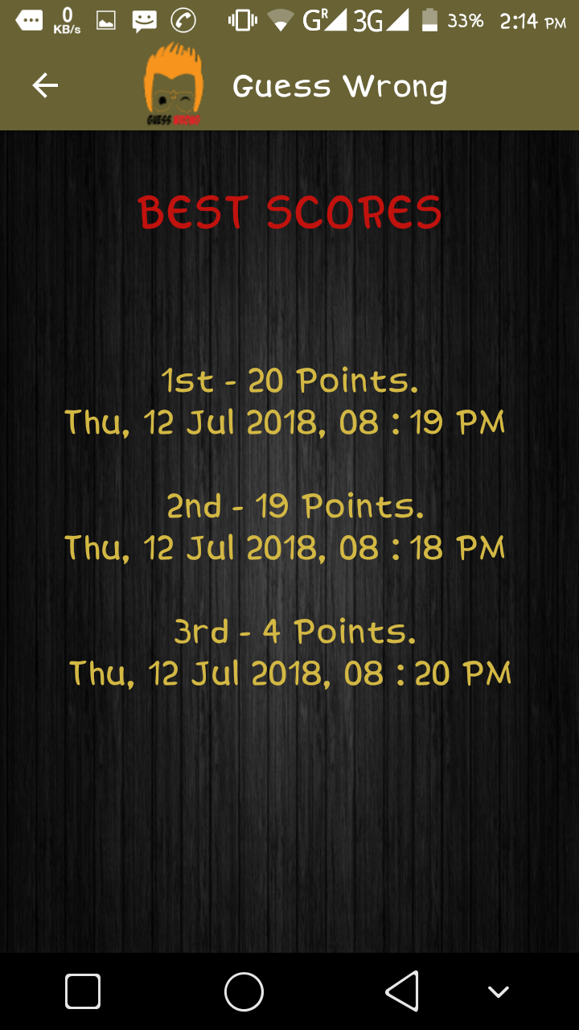

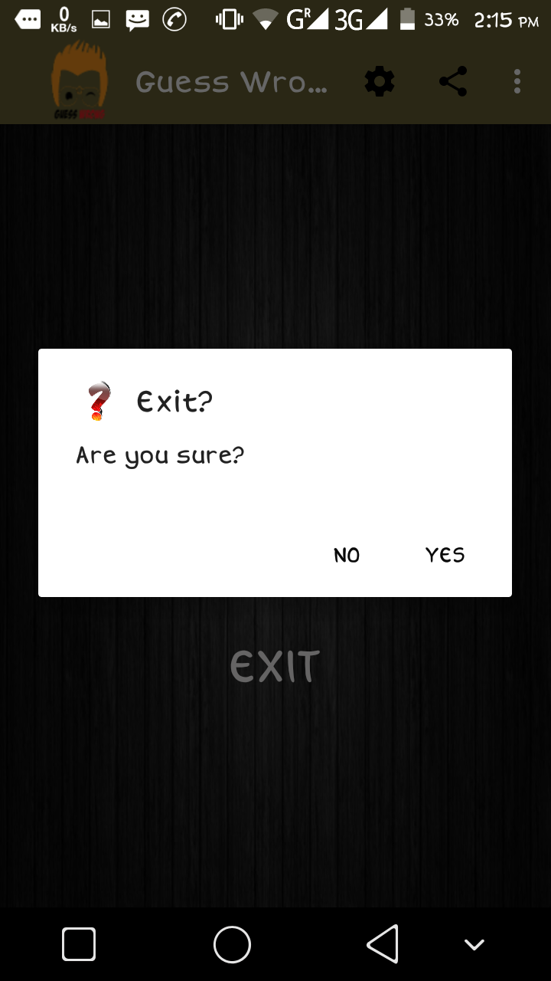

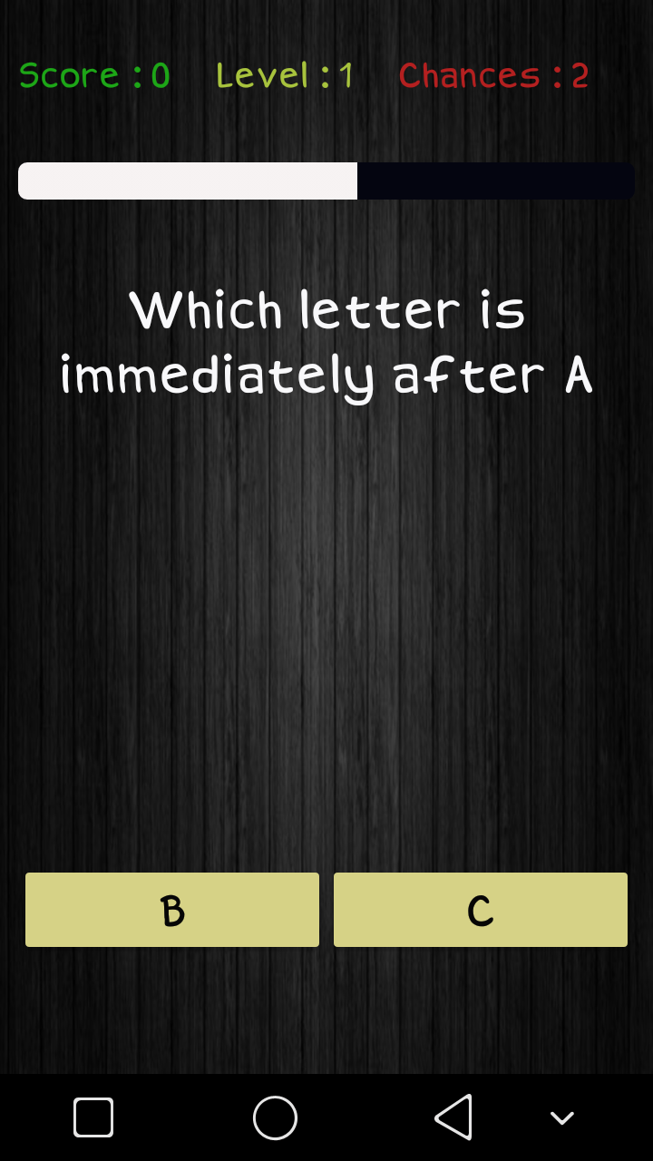

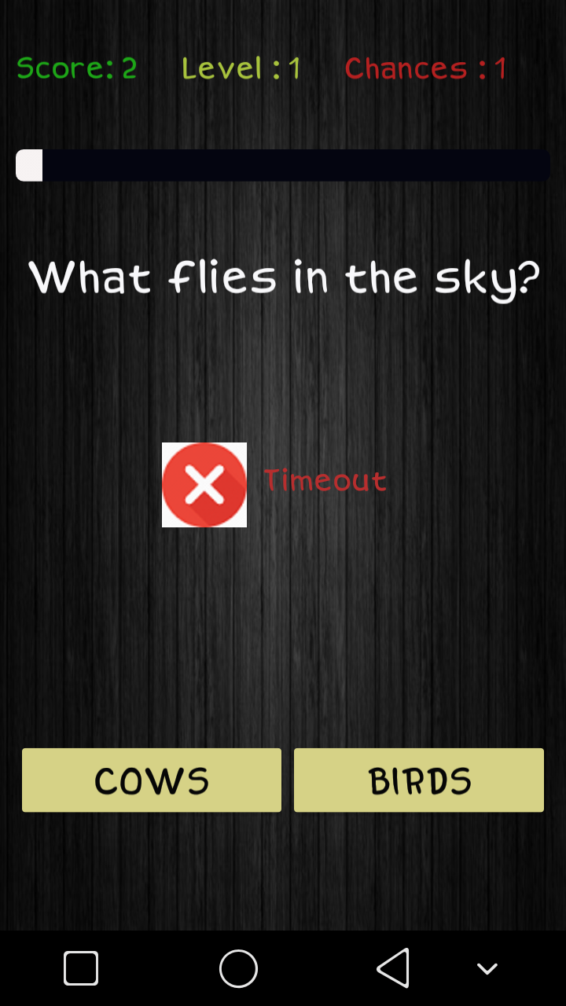

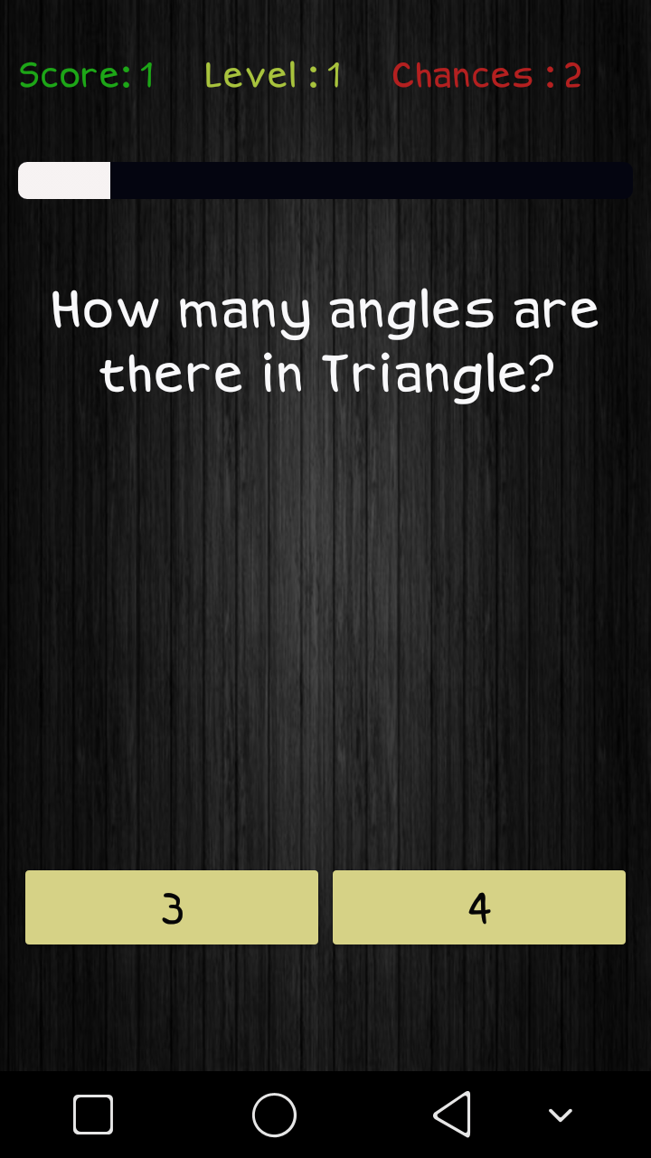

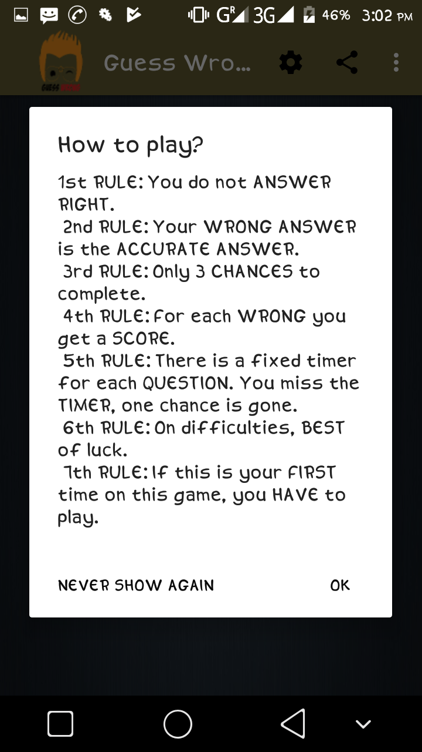

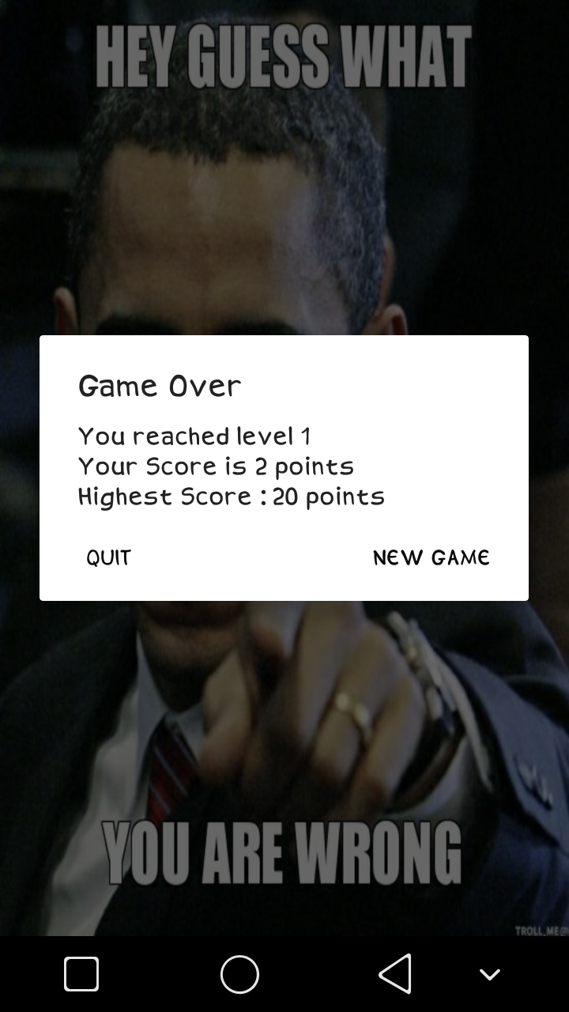

|  |
| --- |
| **Chapter – Five**  **Limitations & Conclusion** |

**5.1 Limitation**

We think there are few limitations in our software.

These are follows:

* The game is offline game.
* It does not contain database to store user information.
* No personal user profile.

**5.2 Future implementation**

Several future implementations can be made. These are follows:

* It can be connected through database.
* The levels can be updated with several questions.
* User Interface can be updated further.
* It can be developed for iOS.

**5.3 Conclusion**

Guess Wrong is a game for fun purpose. It is made to check how human brain reacts to choose wrong answers where they know the right one. With furthermore difficulties it will be more fun to play. Hope the game will be played and entertain all the users in future.